A)
#include <stdio.h>
#include <stdlib.h>
int main()
{
int *a, *b;
a = (int *)malloc(5 * sizeof(int));
b = (int *)calloc(5, sizeof(int));
a = (int *)realloc(a, 10 * sizeof(int));
free(a);
free(b);
return 0;
}

OUTPUT:
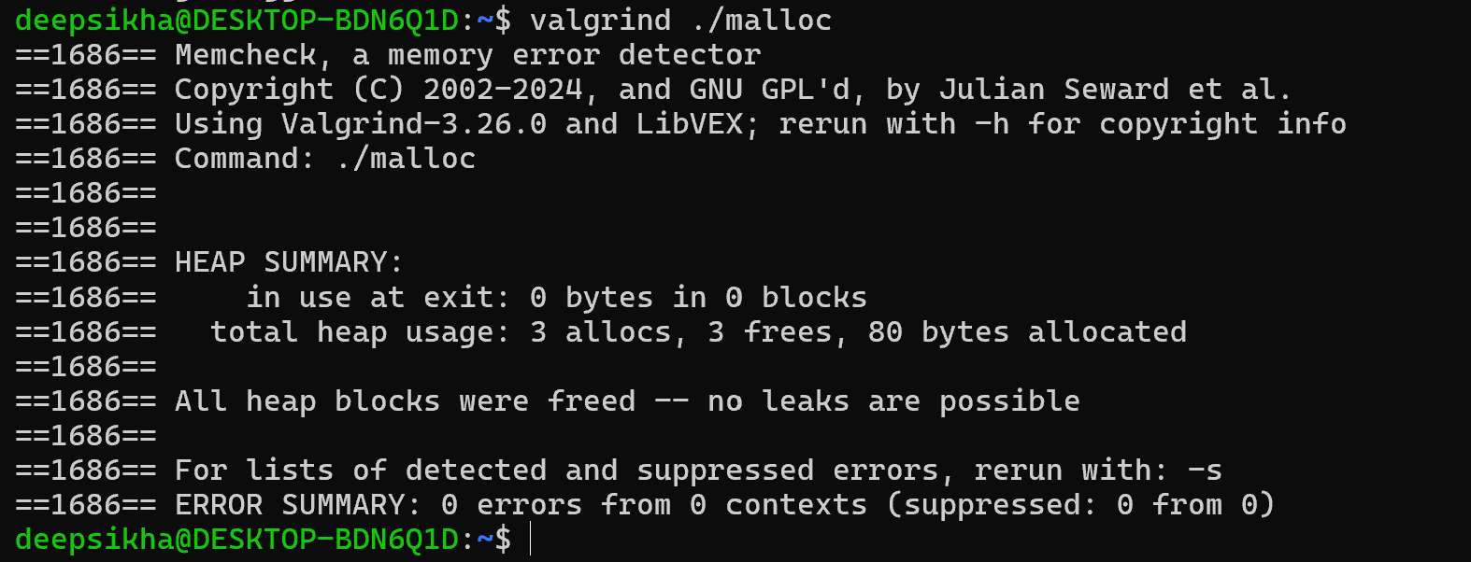
B)
#include <stdio.h>
#include <unistd.h>
int main()
{
int x = 100;
if(fork() == 0)
{
printf("Child Before=%d\n", x);
x = 500;
printf("Child After=%d\n", x);
}
else
{
sleep(2);
printf("Parent=%d\n", x);
}
return 0;
}
OUTPUT:
